**Install Vbox**

1 - <https://www.virtualbox.org/> , install vbox and its update plugin: VM VirtualBox Extension Pack

2 - On newer machines, you may need to enable virtualization in the bios to be able to be able to install 64bits virtual machines; (Intel virtualization and sometimes VT-X option); on some versions of Windows 10 you also need to disable HyperV (the microsoft virtual machine installed by default),.

3 - Use the iso of your favorite system to perform the instal <https://www.ubuntu.com/>

**Some first steps**

1 - Host button is right control by default; [Host+F] toggles full screen.

2 - By default in **Ubuntu** and Linux Mint the **terminal shortcut** key is mapped to Ctrl+Alt+T. Ctrl+Shift+T = terminal in a new tab

Super key >3 seconds => list of shortcuts

**Enabling copy/paste between host and virtual machine**

1 - Enable the feature in virtual box menu

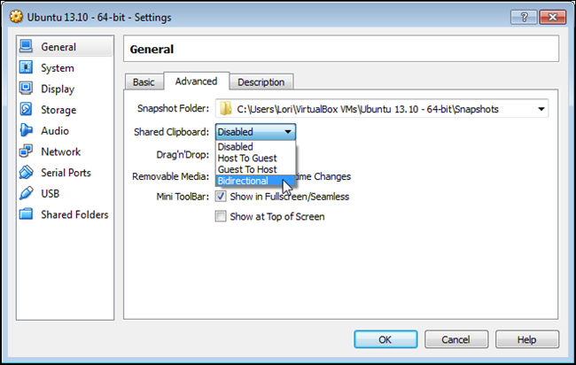

2 - install the package **virtualbox-guest-additions-iso** in the **client** Ubuntu with the commandT6y7u

sudo apt-get install virtualbox-guest-dkms virtualbox-guest-utils virtualbox-guest-x11

**Resolving DNS/Wins**

1 - install samba: sudo apt-get install samba

2 - some names may be resolved with nslookup but not with ping (and all the other dns users): edit the /etc/avahi/avahi-daemon.conf file (then sudo service avahi-daemon restart)

to link .alocal and .local

[server]

domain-name=.alocal